**Report: Website Development for**

**Berimbolo Security**

**Cover Page**

**Name:** Shorouk Mohammed Helme  
**School Name:** We Mansoura  
**Task Number:** U6Task2  
**Date:** 25/11/2024

**Table of Contents**

1. Introduction
2. Identification of User Requirements
   * Business Owners’ Requirements
   * End Users’ Requirements
   * Additional Information (Removed)
3. Visual Designs for Pages
   * Layouts of Main Pages
   * Color Schemes and Typography
   * Key Elements and Features
4. Alternative Design Options
   * Layout Options
   * Alternative Colors
   * Structure Options
5. Technical Documentation
   * Tools and Platforms
   * Security Features
   * SEO and Performance Optimization
   * Compatibility with Devices and Browsers
6. Project Link and Visuals
7. Conclusion

**1. Introduction**

This report presents a plan for designing and developing a new website for **Berimbolo Security**. The goal of the website is to improve communication with customers, showcase products and services, and make company information accessible.

The report covers user requirements, visual design of pages, alternative design options, and technical documentation to ensure the website achieves its goals.

**2. Identification of User Requirements**

**Business Owners’ Requirements**

1. Easy access to company information, such as services offered and contact details.
2. Showcase products and installation services for security systems.
3. Provide a platform for customer inquiries and service bookings.
4. Integration of customer testimonials and case studies.
5. A mobile-friendly design for various devices.
6. SEO-optimized pages to improve visibility.

**End Users’ Requirements**

1. Clear navigation and intuitive layout.
2. Fast access to product and installation information.
3. A responsive design that works seamlessly across all devices.
4. Secure browsing experience, especially for form submissions.
5. Ability to browse services by category (e.g., home security, business security).
6. The option to request a quote or book a service online.

**Additional Information (Removed)**

There was a section titled "Additional Information," but it has been removed based on the user's request, as it was not considered important.

**3. Visual Designs for Pages**

**Layouts of Main Pages**

* **Home Page:** Includes a header, service banners, product sections, customer
* 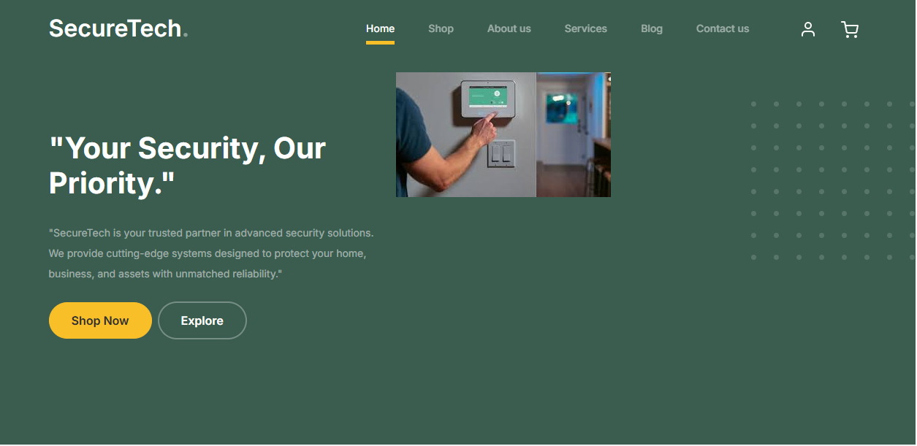
* testimonials, and contact links.
* **Shop Page**  
  The Shop page is one of the most important sections of the "Aman" camera website, providing a seamless and convenient shopping experience. It features a wide selection of cameras and related equipment, organized by type or purpose to make browsing easier. Each product page includes detailed descriptions, high-quality images, specifications, and prices. The page also includes filtering options and an advanced search feature to help users find products quickly. A secure and straightforward checkout process ensures a hassle-free shopping experience, with the site designed to be responsive for easy access across smartphones, tablets, and desktop computers.
* 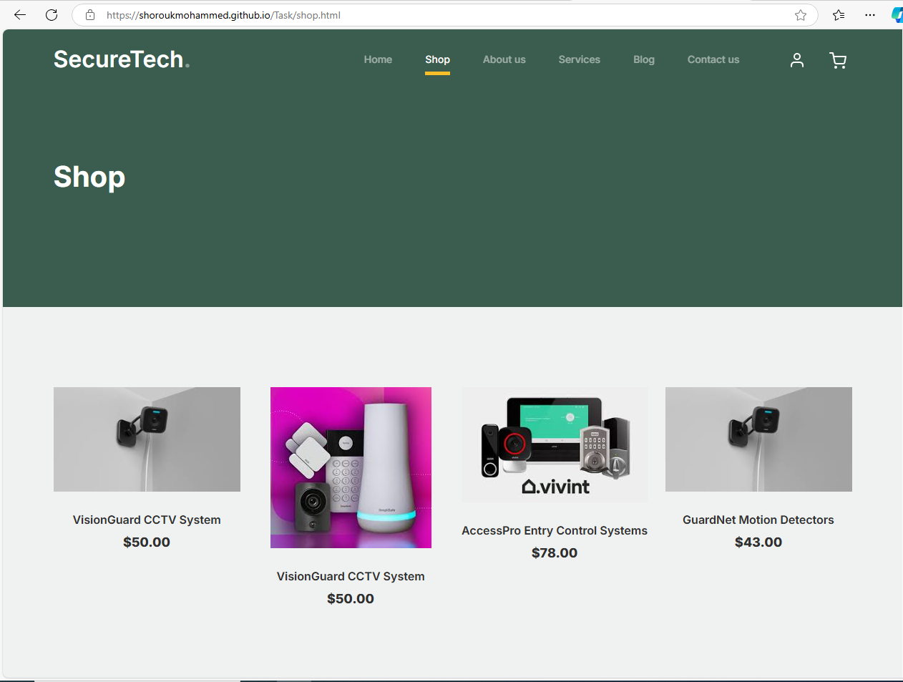
* **About Us Page**  
  The About Us page on the "Aman" camera website offers a comprehensive overview of the company’s vision, mission, and history. It introduces visitors to the core values of the company, such as quality, innovation, and professionalism in offering camera products and services. This page may also include information about the founding team and notable achievements, building trust and credibility with visitors. The aim is to create a welcoming atmosphere where users feel confident in the brand and its products.
* 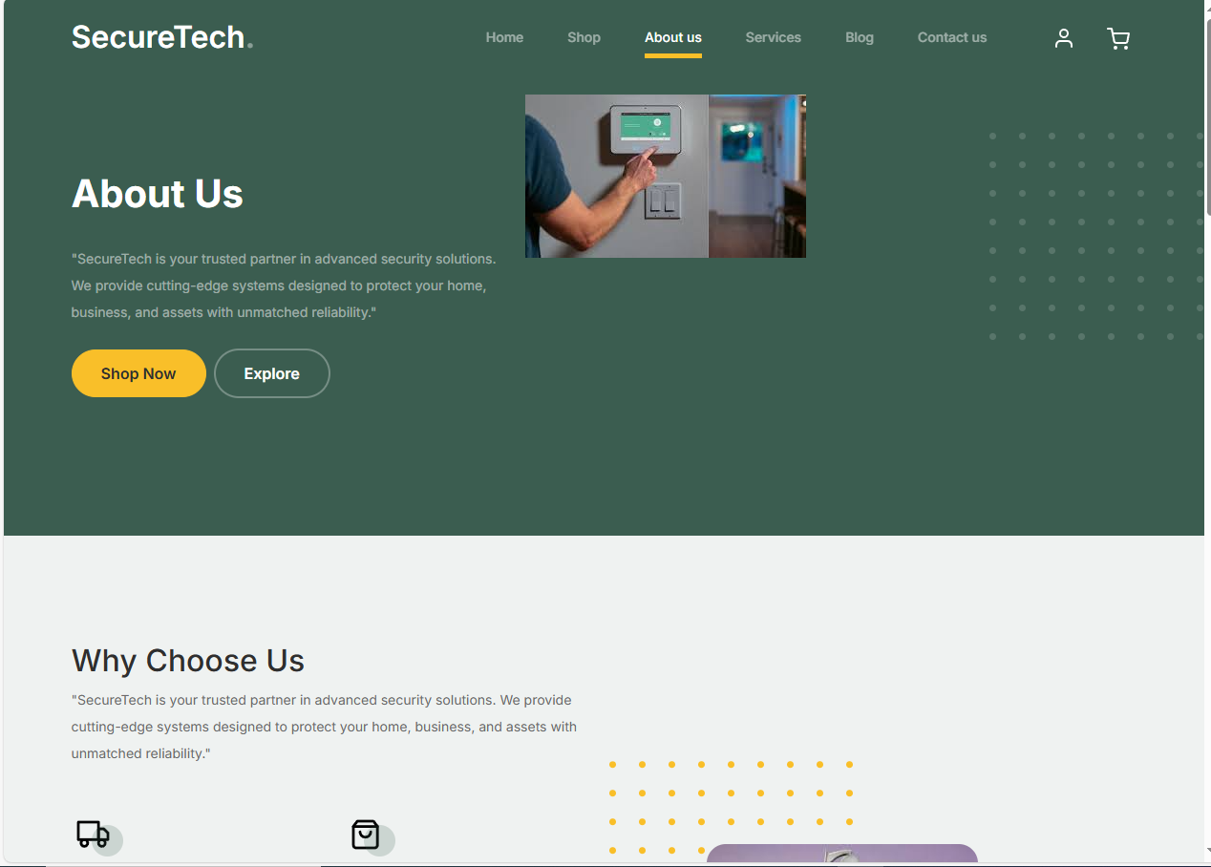
* **Products Page:** Displays products categorized with images and descriptions for each product.
* **Blog Page**  
  The Blog page on the "Aman" camera website is an essential resource for sharing valuable knowledge and insights with visitors. It features articles on the latest trends in camera technology, tips for using cameras effectively, and detailed product reviews. The blog also includes company updates and news, helping keep visitors informed and engaged. This page is designed for easy navigation, allowing users to browse articles by category or date, enhancing user experience and interaction with the content.
* 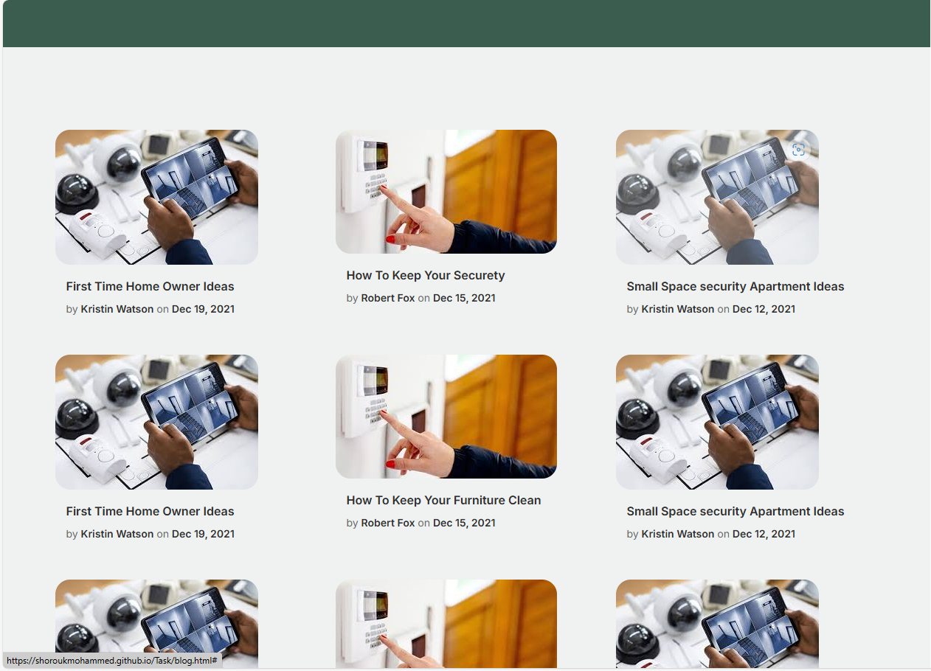

**Contact Page:** Contains a simple contact form with location and contact details.

* 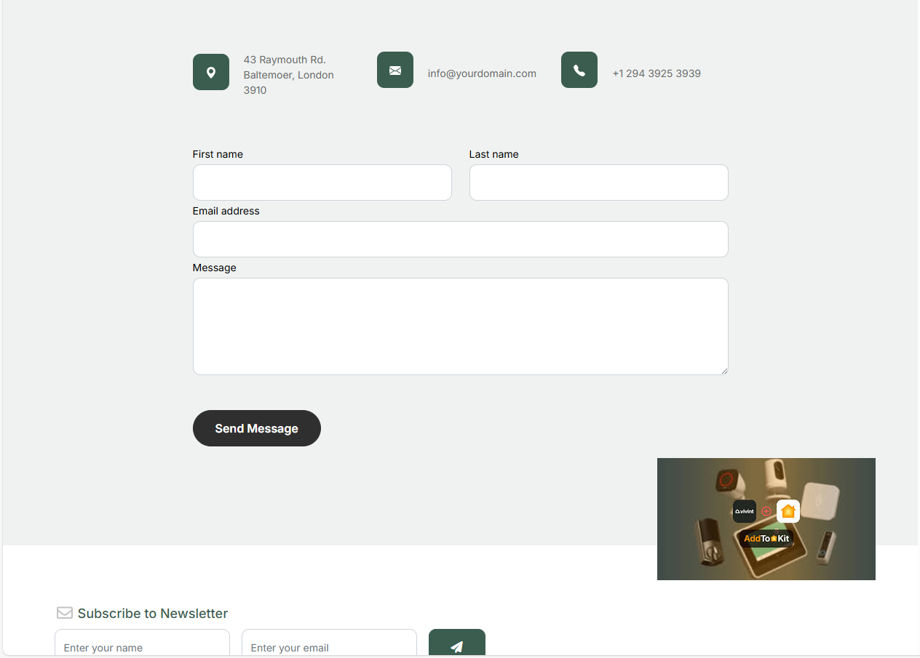

**Color Schemes and Typography**

* **Colors:** Blue for security, white for cleanliness and simplicity, and gray for modernity.
* **Fonts:** Simple fonts like Arial or Calibri for easy reading.

**Key Elements and Features**

* Call-to-action (CTA) buttons such as “Request Now” and “Book Service.”
* Interactive product gallery.
* Search bar with filtering options for products.

**4. Alternative Design Options**

**Layout Options**

* A sidebar navigation instead of top navigation.
* Use full-screen images as a banner on the homepage.

**Alternative Colors**

* Green for an environmentally friendly feel.
* Dark design to create a more modern look.

**Structure Options**

* A single-page website for easy navigation.
* A multi-page structure with detailed sections for each service.

**5. Technical Documentation**

**Tools and Platforms**

* HTML, CSS, and JavaScript for development.
* Bootstrap for responsive design.
* Hosting the site on GitHub Pages or Netlify.

**Security Features**

* HTTPS for secure browsing.
* Form validation to prevent spam and ensure data integrity.

**SEO and Performance Optimization**

* Optimizing page load speeds by reducing image and file sizes.
* Using keywords to improve search engine rankings.

**Compatibility with Devices and Browsers**

* Testing the website on Chrome, Firefox, Safari, and Edge browsers.
* Ensuring the website is responsive and works well on desktop, tablet, and mobile devices.

**6. Project Link and Visuals**

**Website Link:**  
<https://shoroukmohammed.github.io/Task/>

**Project Image:**

**Responsive :**

**Responsive Design**

**The website features a responsive design that ensures full compatibility with various types of devices and screen sizes, including desktop computers, tablets, and smartphones. This design adjusts and formats content automatically to fit the screen being used, providing a seamless and efficient user experience regardless of the device.**

**This feature is a fundamental element for enhancing user experience, as it allows easy and clear access to content, reducing the need to zoom in or out. Additionally, the responsive design improves the arrangement of elements and content, ensuring everything is well-positioned, which enhances the site’s appeal and ease of use.**

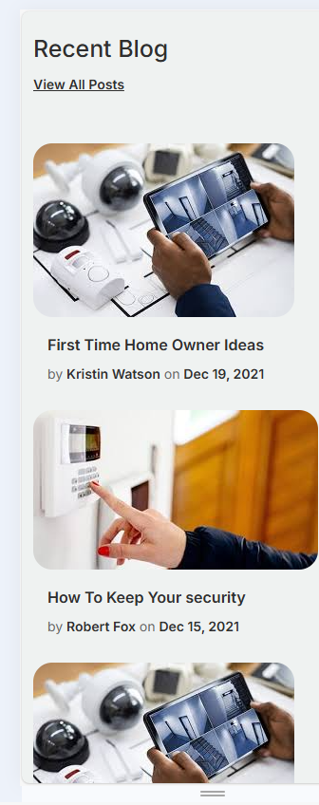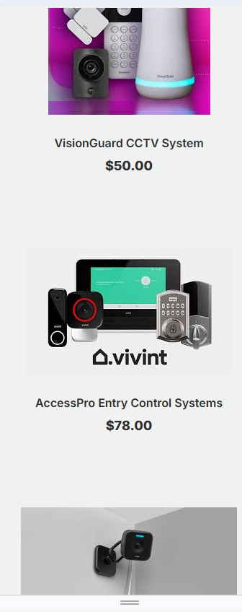

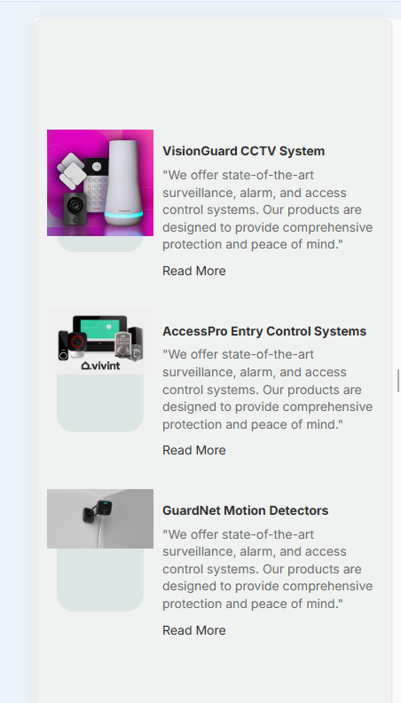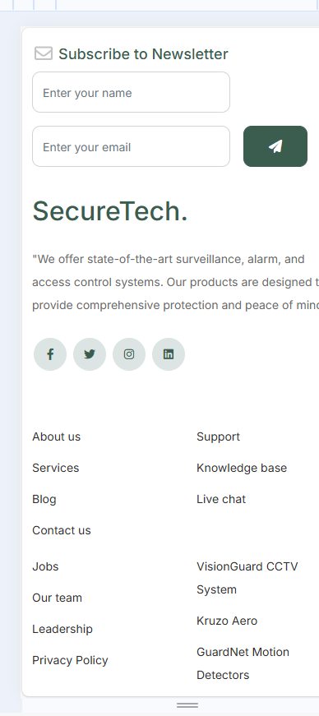

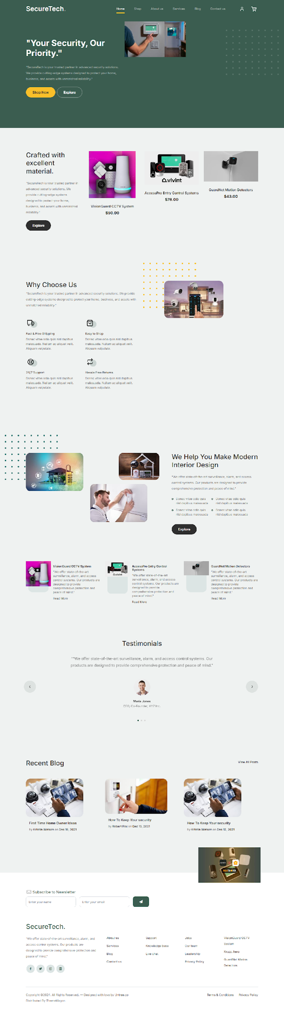

**7. Conclusion**

This design plan aims to meet the needs of both the business owners and end-users. The website will serve as an effective platform to promote **Berimbolo Security’s** services and products while providing an excellent user experience.

**File Submission:**  
ShoroukMohammedHelme_WeMansoura_U6Task2.docx

**Date:** 25/11/2024